StreamHorizon –
Target Database Connectivity Guide
Version 3.2.x
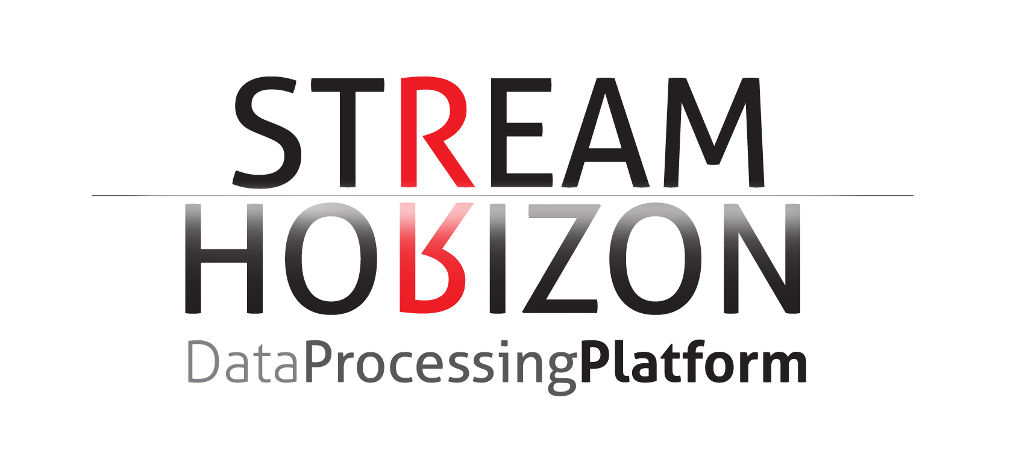

Table of Contents
Introduction 3
About this guide 3
Database connectivity 3
Target database connectivity 3
Multiple database targets 3
Setting target database connection parameters <connectionProperties> 3
<jdbcPoolSize> 4
other target dtabase connection parameters 4
<databaseStringLiteral> 4
<databaseStringEscapeLiteral> 5

Introduction

About this guide
This document elaborates in more detail about target database connectivity properties of StreamHorizon platform. Condensed version of this document can be found in file streamHorizonQuickXMLTutorial_engine_config.xml. This file is supplied with installation of StreamHorizon and will be sufficient for non-junior IT staff. Document is located in $ENGINE_HOME/config/streamHorizonQuickXMLTutorial_engine_config.xml
While reading this guide you should try to (in parallel) check the following sources of information:
- $ENGINE_HOME/config/streamHorizonQuickXMLTutorial_engine_config.xml
- $ENGINE_HOME/demo_sales/mssql/engine-config-JDBC-example.xml
- $ENGINE_HOME/demo_sales/mssql/engine-config-BULK-INSERT-example.xml
- $ENGINE_HOME/demo_sales/oracle/ext-table-deploy/engine-config-example.xml
- $ENGINE_HOME/demo_sales/oracle/jdbc-deploy/engine-config-example.xml
- $ENGINE_HOME/demo_sales/oracle/pipe-deploy/engine-config-example.xml

Listed xml files contain examples of all basic StreamHorizon deployment configurations and settings.

This document aims to present all parameters & settings ordered by topic rather than list them as they physically appear in xml configuration examples of StreamHorizon.

Database connectivity

Target database connectivity

Data processing projects usually have one or more target databases. Processed data is loaded into target database after it was received from the source (message queue, database, file, RPC, streaming etc…). StreamHorizon has one target database you can point it towards in engine-config.xml settings file.

Multiple database targets

- Single StreamHorizon can talk to multiple target databases if you set your target database to have synonyms or database links to another database instances.

- If you deploy more than one StreamHorizon instance you can ensure that your StreamHorizon software stack can talk to multiple target databases.

Setting target database connection parameters <connectionProperties>
Element <connectionProperties> of engine-config.xml encapsulates settings for connectivity to the target database. Adequate examples are given in *.xml files.

<jdbcPoolSize>
Element of <connectionProperties> setting determines number of total jdbc connections against target database. Note that this element is in use in jdbc, pipe and bulk operation mode of StreamHorizon. It is crucial that sufficiently large number of connections is allocated. This ensures that connections aren’t reused (by the connection pool) between data processing threads of StreamHorizon. Reusing of connections will reduce throughput of StreamHorizon.
The <jdbcPoolSize> setting must be integer equal or greater than:
number of dimensions defined in your target database +
number of your etl threads <etlProcessingThreadCount> +
contingency of 10 additional connections

Example: if you have 10 dimensions in your model and 50 etl threads < etlProcessingThreadCount> and 50 db threads <bulkLoadProcessingThreads> inserting into fact table connection pool should have minimum of 10+50+50 dimensions. For contingency set this parameter to 10+50+50+10. It is important to avoid reusing of jdbc connections by connection pool of fact loader processes as this can be detrimental for performance.
NOTE: If you run db load using MSSQL and BULK INSERT statement you will not need to add connections for db loaders into your total <jdbcPoolSize> size. Reason being that these connections are made externally by Windows batch file (not by StreamHorizon). Same reasoning applies if you use Oracle in pipe mode.

other target dtabase connection parameters

<databaseStringLiteral>

Above property will be used by StreamHorizon to enclose string values passed to the database. Required value for most of databases is single quote which is default value provided in config files.

Example:

If StreamHorizon has following SQL statement in config file:
<insertSingleRecord>
insert into dimensionTableName1(dimensionSurrogateKey, tableAttribute1, tableAttribute2) values (dimensionSequenceName.nextval,'${dataAttributeName_1}',${dataAttributeName_2})
</insertSingleRecord>

If value of context variable dataAttributeName is AAA for example, StreamHorizon will substitute AAA with ‘AAA’ before it executes sql statement above against database. This is, of course, case if <databaseStringLiteral> value is set to single quote:

<databaseStringLiteral>’<databaseStringLiteral/>

Arbitrary example of substituted sql isnert statement by StreamHorizon could be:

<insertSingleRecord>
insert into dimensionTableName1(dimensionSurrogateKey, tableAttribute1, tableAttribute2) values (dimensionSequenceName.nextval,'AAA','${dataAttributeName_2}')
</insertSingleRecord>

<databaseStringEscapeLiteral>

If database string contains <databaseStringLiteral/> for example, and if string which need to be passed to the database should have value AA’A, such string will need be adequately escaped. Most of databases escape string literal with double quote. This means that string passed to the database (by StreamHorizon) need be ‘AA’’A’ in order for database to store string value AA’A in the table.

For example given above <databaseStringEscapeLiteral> needs to be set to two consecutive single quotes:

<databaseStringEscapeLiteral>’’ <databaseStringEscapeLiteral>

Above is the default setting of supplied config parameters.

